Phase 5

Lesson 4

**Container Deployment Using Docker Swarm**

This section will guide you to**:**

* Deploy a Docker container on Docker swarm for orchestration.

Steps:

1. Setting up a Docker instance

2. Building a custom Docker image to be deployed

3. Initializing a Docker swarm cluster and deploying a container to the cluster

4. Pushing the code to GitHub repositories

**Step 1:** Setting up a Docker instance

* Docker version 20.10.7 is installed
* Type the following command to check the docker version installed on lab:

**docker version**

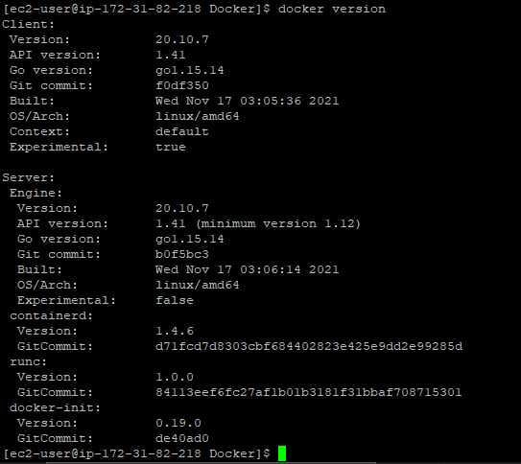

**Step 2:** Building a custom Docker image to be deployed

* First, clone the Git repository on Docker host using the command below:

**git clone** [**https://github.com/Anuj1990/Docker.git**](https://github.com/Anuj1990/Docker.git)

* Run with docker build command to build a custom Docker image

**cd Docker**

**docker build -t phpcode . -f Dockerfile**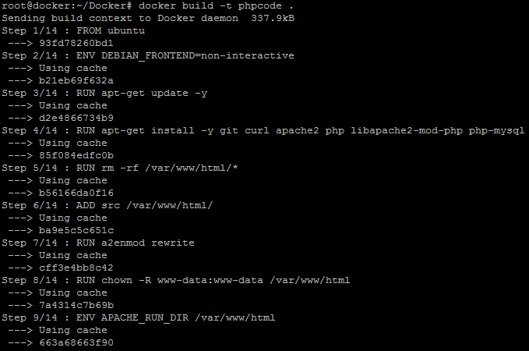

* Once the image is built, check if it is built properly or not. You can see a Docker image entry using Docker images command



**Step 3:** Initializing a Docker swarm cluster and deploying a container to the cluster

* First, we need to initialize Docker swarm using the set of commands given below:

**docker swarm init**

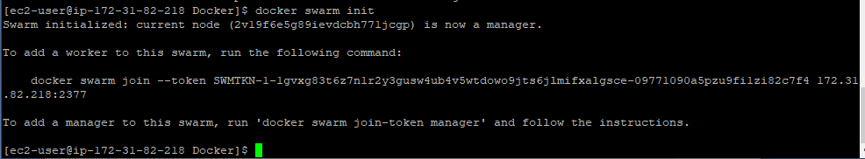

**docker node ls**



* Once the node is configured, deploy the custom Docker image on the Docker swarm cluster following the process shown below

**docker service create -p 80:80 --name webserver phpcode**

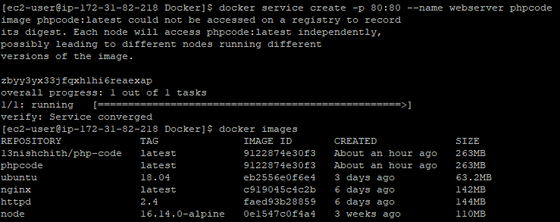

**docker service ls**

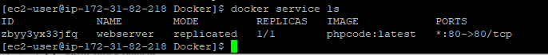

**curl localhost**

